**ITALY INTERVENTIONAL CARDIOLOGY DEVICES MARKET**

According to Intelli, the Italy interventional cardiology devices market was valued at USD 15,567.13 million in 2024 and is projected to reach 24463.51 at a CAGR of 7.5% from 2024 to 2032.

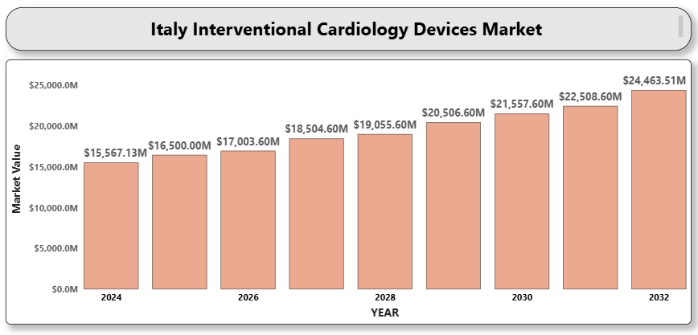

The Italian interventional cardiology devices market is currently facing a downturn due to a mix of factors, including budgetary constraints in public hospitals, delayed elective cardiovascular procedures post-pandemic, and stringent regulatory pathways affecting the introduction of new technologies. Despite having a historically robust healthcare system, Italy's aging infrastructure, slow procurement processes, and a declining rate of cardiovascular interventions are impacting market growth.

Nevertheless, innovation in minimally invasive techniques, next-generation drug-eluting stents, and intravascular imaging are expected to create pockets of opportunity. While the overall market is contracting, specialized segments such as robotic-assisted PCI and AI-driven diagnostics are gaining attention. Moreover, private healthcare institutions are showing rising interest in premium devices, which could slightly buffer the decline.

**Italy Interventional Cardiology Devices Market Definition**

Interventional cardiology devices are a category of medical devices used in minimally invasive procedures to diagnose and treat cardiovascular conditions such as coronary artery disease, structural heart defects, and peripheral vascular conditions. These devices include balloon catheters, stents (bare-metal and drug-eluting), guidewires, intravascular ultrasound (IVUS) systems, and atherectomy devices. These tools are critical in percutaneous coronary interventions (PCI) and other catheter-based procedures performed under fluoroscopic guidance.

**Italy Interventional Cardiology Devices Market Overview**

The interventional cardiology devices market in Italy is under transition. The demand for cardiac procedures remains high due to an aging population and the high prevalence of ischemic heart disease. However, delayed reforms in hospital procurement policies and price pressures exerted by government-funded health services have slowed the growth of the market.

Italy’s National Recovery and Resilience Plan (PNRR), part of the EU post-COVID stimulus, has allocated funding for digital and technological upgrades in healthcare. This initiative is expected to modernize interventional labs and encourage uptake of advanced imaging and diagnostic tools in cardiology. Yet, reimbursement delays, device commoditization, and increasing operational costs continue to challenge manufacturers.

**Italy Interventional Cardiology Devices Market Segmentation Analysis**

**Market Segmentation by Product Type:**

* Coronary Stents (DES, BMS, Bioresorbable)
* Catheters (Balloon, Guiding, Diagnostic)
* Guidewires
* Intravascular Ultrasound (IVUS)
* Fractional Flow Reserve (FFR) Devices
* Atherectomy Devices
* Others

**Coronary stents** dominate the Italian market due to their central role in PCI. Drug-eluting stents (DES) remain the standard of care, although newer technologies like bioresorbable scaffolds are entering niche segments.

**Market Segmentation by End-User:**

* Hospitals
* Cardiac Centers
* Ambulatory Surgical Centers (ASCs) A close-up of hands holding a tablet and a pen

  Description automatically generated
* Research & Academic Institutions

Hospitals are the largest end-users, especially public tertiary care institutions. However, **private cardiac centers** are gradually capturing market share by offering faster access to advanced procedures and shorter waiting times.

**Market Segmentation by Application:**

* Coronary Artery Disease
* Valvular Heart Disease
* Congenital Heart Defects
* Others

**Coronary artery disease (CAD)** remains the key driver of demand, though increasing awareness of structural interventions (e.g., TAVR, MitraClip) is expanding the procedural mix.

**Key Players**

This report includes detailed profiles and analysis of the following companies:

* Abbott Laboratories
* Boston Scientific Corporation
* Medtronic plc
* Terumo Corporation
* Cardinal Health
* Biotronik SE & Co. KG
* B. Braun Melsungen AG
* Edwards Lifesciences Corporation
* Koninklijke Philips N.V.
* Siemens Healthineers AG

**

* In 2024, Terumo Europe opened a new training center in Italy for hands-on interventional cardiology workshops, expanding local expertise in radial access procedures.
* In 2024, Edwards Lifesciences expanded its TAVR (transcatheter aortic valve replacement) program across leading private institutions in northern Italy.
* In 2023, Abbott introduced its Ultreon 1.0 Software for OCT imaging in Italian hospitals, improving coronary visualization.

**Market Attractiveness**

Although the Italian market is experiencing negative growth, niche opportunities in structural heart interventions, robotic-assisted procedures, and AI-enhanced diagnostics offer moderate investment attractiveness. Regions with higher private healthcare penetration, such as Lombardy and Veneto, remain more open to premium and innovative devices.

**Porter’s Five Forces Analysis**

* **Bargaining Power of Suppliers:** Moderate (few highly specialized component manufacturers)
* **Bargaining Power of Buyers:** High (government procurement dominates)
* **Threat of New Entrants:** Low (high regulatory and capital barriers)
* **Threat of Substitutes:** Low (limited alternatives to device-based interventions)
* **Industry Rivalry:** High (price competition among leading brands)

**TABLE OF CONTENTS**

**1. INTRODUCTION OF ITALY INTERVENTIONAL CARDIOLOGY DEVICES MARKET**  
1.1 Overview of the Market  
1.2 Scope of Report

**2. EXECUTIVE SUMMARY**

**3. RESEARCH METHODOLOGY**  
3.1 Data Mining  
3.2 Validation  
3.3 Primary Interviews  
3.4 List of Data Sources

**4. ITALY INTERVENTIONAL CARDIOLOGY DEVICES MARKET OUTLOOK**  
4.1 Overview  
4.2 Market Dynamics  
4.2.1 Drivers    
4.2.2 Restraints    
4.2.3 Opportunities    
4.2.4 Trends    
4.3 Porters Five Force Model  
4.4 Value Chain Analysis

**5. ITALY INTERVENTIONAL CARDIOLOGY DEVICES MARKET, BY PRODUCT TYPE**  
5.1 Angioplasty Balloons  
5.2 Angioplasty Stents  
5.3 Catheters  
5.4 Plaque Modification Devices  
5.5 Hemodynamic Flow Alteration Devices  
5.6 Others

**6. ITALY INTERVENTIONAL CARDIOLOGY DEVICES MARKET, BY END USER**  
6.1 Hospitals  
6.2 Specialty Clinics  
6.3 Ambulatory Surgical Centers (ASCs)

**7. ITALY INTERVENTIONAL CARDIOLOGY DEVICES MARKET, BY GEOGRAPHY**  
7.1 Northern Italy  
7.2 Central Italy  
7.3 Southern Italy

**8. ITALY INTERVENTIONAL CARDIOLOGY DEVICES MARKET COMPETITIVE LANDSCAPE**  
8.1 Overview  
8.2 Company Market Ranking  
8.3 Key Development Strategies

**9. COMPANY PROFILES**  
**9.1 Medtronic PLC**9.1.1 Overview    
9.1.2 Financial Performance    
9.1.3 Product Outlook    
9.1.4 Key Developments    
**9.2 Abbott Laboratories**9.2.1 Overview    
9.2.2 Financial Performance    
9.2.3 Product Outlook    
9.2.4 Key Developments    
**9.3.1 Overview    
9.3.2 Financial Performance    
9.3.3 Product Outlook    
9.3.4 Key Developments    
**9.4 B. Braun Melsungen AG**9.4.1 Overview    
9.4.2 Financial Performance    
9.4.3 Product Outlook    
9.4.4 Key Developments    
**9.5 Terumo Corporation**9.5.1 Overview    
9.5.2 Financial Performance    
9.5.3 Product Outlook    
9.5.4 Key Developments    
**9.6 BIOTRONIK**9.6.1 Overview    
9.6.2 Financial Performance    
9.6.3 Product Outlook    
9.6.4 Key Developments    
**9.7 Cardinal Health**9.7.1 Overview    
9.7.2 Financial Performance    
9.7.3 Product Outlook    
9.7.4 Key Developments    
**9.8 Cook Medical**9.8.1 Overview    
9.8.2 Financial Performance    
9.8.3 Product Outlook    
9.8.4 Key Developments    
**9.9 Koninklijke Philips N.V.**9.9.1 Overview    
9.9.2 Financial Performance    
9.9.3 Product Outlook    
9.9.4 Key Developments    
**9.10 Siemens Healthineers AG**  
9.10.1 Overview    
9.10.2 Financial Performance    
9.10.3 Product Outlook    
9.10.4 Key Developments

**10. KEY DEVELOPMENTS**  
10.1 Product Launches/Developments  
10.2 Mergers and Acquisitions  
10.3 Business Expansions  
10.4 Partnerships and Collaborations

**11. APPENDIX**  
11.1 Related Research